The George Atkins Communication Award
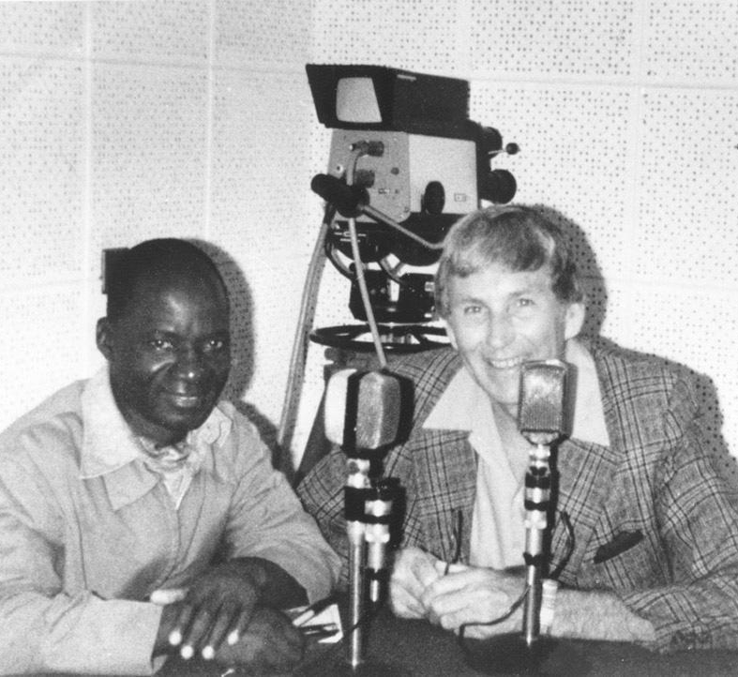
This award recognizes individual radio broadcasters for their outstanding commitment and contribution to food security and poverty reduction in low-income countries.

It is presented each year to broadcasters who demonstrate overall excellence in responding to the needs of small-scale farmers and rural people, as well as a strong partnership with Farm Radio International.

This award is named after George Atkins, the Founding Director of Farm Radio International.
To be eligible for the award:

- You must work at a radio station that has been a Farm Radio International broadcasting partner for a minimum of one year.
- You must have at least three years of experience as a radio broadcaster. This includes time spent volunteering as a broadcaster.

Past winners of the George Atkins Communication Award are not eligible to apply for 5 years after receiving the award. If you're not sure if you’re eligible, please contact radio@farmradio.org.

To apply for the award, complete and email this application form to one of the addresses below, along with a photo of yourself working as a broadcaster.

Winners of the George Atkins Communication Award receive $500 CAD and a certificate, to be awarded at a prize ceremony. The deadline to apply is October 9, 2026.

Please send your application to one of the following email addresses, depending on where you live, and include “George Atkins Communication Award” in the subject line.

- Burkina Faso: burkinafaso@farmradio.org
- Ethiopia: ethiopia@farmradio.org
- Ghana: ghana@farmradio.org
- Tanzania: tanzania@farmradio.org
- Uganda: uganda@farmradio.org

If you live in another country, please send your application form to: radio@farmradio.org
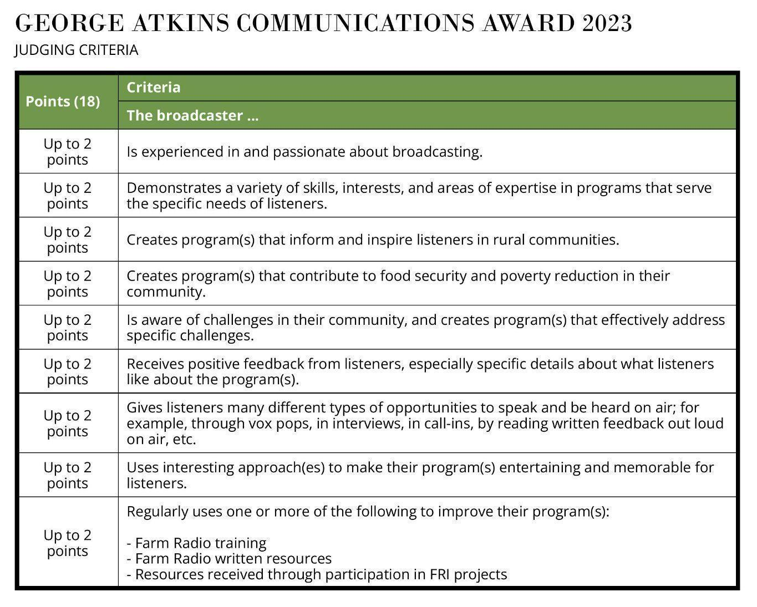
Application form for the George Atkins Communication Award

Please answer each of the following questions with as much detail as possible. This will increase your chances of winning the award. Tell us about your work as a broadcaster in detail, use examples from your different programs, and include information about all of the segments and features of your programs. Most importantly, tell us stories about your journey as a broadcaster, the impact of your work, and your partnership with Farm Radio International.

Applications will be accepted in English, French, Amharic, Portuguese, Swahili, and Hausa.

You may also submit an audio recording of your answers to the questions, in English or French. Your files must be clearly labelled, including to which questions they apply, and you must still include a written copy of the Broadcaster details.

Broadcaster details:

Full name: _______________________________

Gender: _______________________________

Radio station: _______________________________

Position/job title: _______________________________

Country: _______________________________

City/region: _______________________________

Email address: _______________________________

Phone number: _______________________________

Questions:

1. Please tell us about your career in radio, including what inspired you to become a radio broadcaster. (Describe in 1-2 paragraphs.)

2. How many years have you worked as a broadcaster? This includes time spent volunteering as a broadcaster. Please be specific. (Describe in 1-2 sentences.)

3. What are your strengths, passions, and special areas of expertise as a broadcaster? Please describe how you use these in your programs, particularly to inspire and inform your listeners. (Describe in 1-2 paragraphs.)

4. Please name and describe the program(s) you currently work on. Focus on the program(s) that serve small-scale farmers and rural communities. What topics do you discuss? (Describe in 1-2 sentences.)

5. What is one major challenge that rural people in your area are facing? Tell us how you became aware of this challenge and tell a story about how your radio program(s) addressed it and helped them overcome it? (Describe in 1-2 paragraphs.)

6. Have you received feedback from your listeners? What do they like about your radio program(s)? Give specific details about how you collect feedback from listeners (call-in programs, letters, etc.) and what listeners have told you. (Describe in 2-3 paragraphs.)

7. How are the voices of listeners included in the radio program? Please explain how you give your listeners the opportunity to speak and be heard on air, and give examples. (Describe in 2-3 paragraphs.)

8. How do you make your program entertaining and memorable for listeners? (Describe in 1-2 paragraphs.)

9. What is your past and/or current experience with Farm Radio International? Please describe your partnership with FRI. Please add any details about training, resources, or support that you have received and how you have used them to improve your radio program(s). (Describe in 1 paragraph.)

10. Please add any other information about yourself that you think is important.

