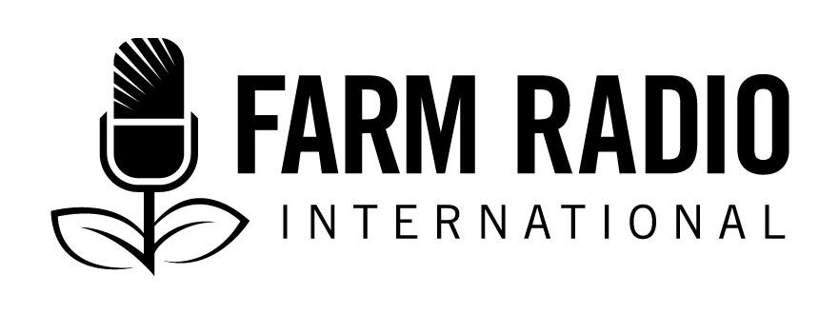
Broadcasting Partner Participation Agreement

Farm Radio International is a Canadian-based organization that supports broadcasters in Africa to develop radio programming that shares knowledge and strengthens the voices of small-scale farmers, their families and their communities.
Why become a broadcasting partner?
A broadcasting partner receives Farm Radio International resources, such as our resource packs, Barza Wire, and broadcaster how-to guides. They can also participate in our online courses and e-Discussions, and all personnel listed on this form will be registered for our online self-guided learning modules.
FRI has more than 900 broadcasting partners in 41 sub-Saharan African countries. Each year, we recognize several outstanding individuals from our broadcasting partners with two awards: the George Atkins Communications Award and the Liz Hughes Award for Her Farm Radio.
Who can be a broadcasting partner?
Any African radio station (or organization) that produces radio programs for farmers can become a broadcasting partner.
Please complete the following information and email the agreement to radio@farmradio.org.

Name of the radio station:

Physical location of radio station (closest city):
Country:
Station email:
Website:
Office phone:

Which languages would you like to receive resources in? Select all that apply.
□ Amharic □ English □ French □ Hausa □ Swahili

Main contact person
The main contact person should be someone in a senior position at the station who can fulfill the expectations outlined at the end of the document.
Name: Gender: □ Male □ Female
Job Title:
Email: Skype:
Mobile phone #: Mobile phone # 2:

Other station contacts
Please provide the names, genders, emails and mobile phone numbers of other people at the station who would like to receive FRI resources by email and phone. We will automatically subscribe these people to Barza Wire and our online learning modules.

- Name:
Gender: □ Male □ Female
Email:
Mobile #:
- Name:
Gender: □ Male □ Female
Email:
Mobile #:
- Name:
Gender: □ Male □ Female
Email:
Mobile #:
- Name:
Gender: □ Male □ Female
Email:
Mobile #:
- Name:
Gender: □ Male □ Female
Email:
Mobile #:
- Name:
Gender: □ Male □ Female
Email:
Mobile #:

About your station
Please provide a brief description of your station / organization’s work. (We encourage you to attach newsletters, annual reports, program schedules, etc.)

What one category best describes your organization:
□ Community radio station
□ Private or commercial radio station
□ Public or government-funded radio station
□ Religious radio
□ Radio network
□ Government department with a radio project
□ Farmers’ organization with a radio project/program
□ NGO with a radio project
□ Production house
□ Other: ________________________
Radio Frequency: (eg: 99.3 FM)
Broadcast range (km):
Estimated audience (total number of listeners):
Wattage:
Broadcast languages (please include all):
Year your station / organization started:
Hours broadcast per day:
Hours broadcasting agriculture / rural programming per week:
What percentage of your programming is dedicated to agriculture / rural development issues?
□ 0-25% □ 26-50% □ 51-75% □ 76-100%

Please describe your agriculture and rural development programming by completing the information below. Use as much space as required. If you have more than 2 programs, please include information about them as well.
Program 1
- Program Name:
- Brief description of the program:
- Program Length:
- Intended Audience:
- Program format(s):
- Day / time program is on air:
- Date (approximate) program started:
- Program produced by:
- Program funded by:
Program 2
- Program Name:
- Brief description of the program:
- Program Length:
- Intended Audience:
- Program format(s):
- Day / time program is on air:
- Date (approximate) program started:
- Program produced by:
- Program funded by:

Agreement & signature

By signing this Agreement, I agree:
a) to use the resources offered by Farm Radio International to serve, as appropriate, small-scale farmers and rural communities, and to share these resources within my organization with all who work on agriculture and rural development-related broadcasting and/or initiatives
b) to provide feedback and information to Farm Radio International using follow-up surveys and other evaluation tools. I understand that Farm Radio International expects me to return at least one completed survey per year, and that my participation as a Broadcasting Partner may be suspended if I consistently fail to provide this feedback
c) to consider contributing stories, news items, resources, and other information to Farm Radio International for distribution to other broadcasting partners
d) to use any revenues derived from the use of Farm Radio International resources to enhance the farm radio activities of my organization
e) to inform Farm Radio International if I leave my present organization, and to inform Farm Radio International of the name and contact information for my replacement

I further agree and warrant that:
a) I am committed to the empowerment of small-scale farmers in my country
b) I have reviewed and am in agreement with Farm Radio International’s Statement of Core Values (attached as an integral part of this Agreement)
c) I am opposed to and in no way condone the use of radio to promote or spread hate and intolerance of others based on ethnicity, race, language, gender, religion, political affiliation, disability, or any other characteristic or attribute.

On behalf of [insert name of station/organization] ________________________________________, I give Farm Radio International permission to publish the information contained in this agreement, and any letters, photographs and other information my organization may from time to time provide.

_______________________ ______________________ ____________________
Name Signature Date

STATEMENT OF CORE VALUES
EQUITABLE DEVELOPMENT: We encourage social and economic change that is beneficial to small-scale farmers and farming families and that is gender inclusive and respectful of cultural diversity.
COMMUNITY SELF-RELIANCE: We encourage community self-reliance and control of local development. We respect local cultures and the voices and decisions of farmers and their communities.
SHARING KNOWLEDGE: We encourage innovation and shared learning by exchanging knowledge.
USE OF MEDIA: We support the use of radio and its integration with new media technologies to ensure that knowledge is shared with the widest appropriate audience.
PARTNERSHIP: We collaborate with a diverse range of broadcasters and other stakeholders to make our work effective.
INTEGRITY AND SOLIDARITY: We encourage journalistic activity that is characterized by accuracy, fairness and balance. We defend media freedom.
ENVIRONMENTAL SUSTAINABILITY: We support practices, policies and technologies that promote sustainable and equitable development. We promote the conservation of natural resources and bio-diversity for the benefit of all.
INTERNATIONAL SOLIDARITY: We favour trade and aid policies that support the efforts of small-scale farmers to create sustainable rural livelihoods.

