Application Form: George Atkins Communication Award

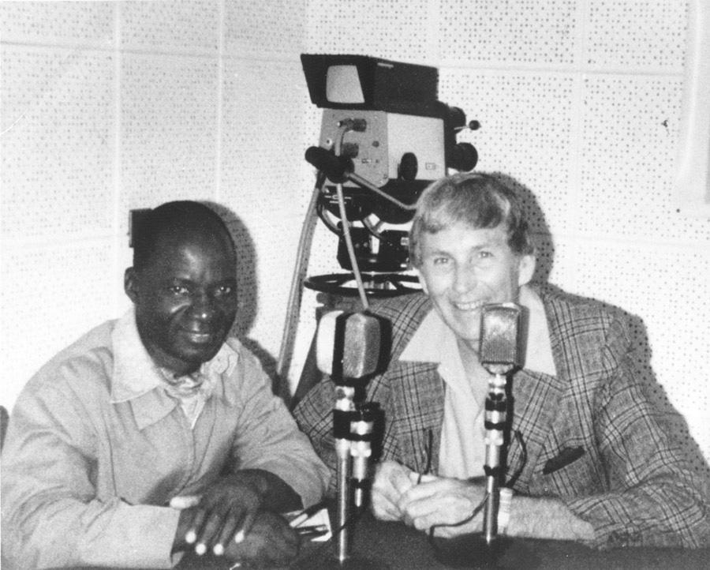
The George Atkins Communications Award was established in 1991 to recognize rural radio broadcasters for their outstanding commitment and contribution to food security and poverty reduction in low-income countries. The award is named after George S. Atkins, the Founding Director of Farm Radio International.

The award is presented each year to an individual who demonstrates overall programming excellence in responding to small-scale farmers' needs as well as commitment to Farm Radio International.

To be eligible for the award, an individual must work at an organization that has been a broadcasting partner of Farm Radio International for a minimum of one year. If you're not sure of your station’s eligibility, please contact radio@farmradio.org.

To apply for the George Atkins Communications Award, send the completed application form, as well as a photo (preferably of you at work in the studio or conducting an interview) and a recording of your program to one of the following email addresses. The deadline to apply is December 21, 2020. Please provide a detailed response to each of the questions in the application form - this will increase your chances of success.

The winner of the George Atkins Communications Award will receive $500 CAD and be awarded a certificate at a prize ceremony.

Please send your application to one of the following email addresses, depending on where you live:

Burkina Faso: burkinafaso@farmradio.org
Ethiopia: ethiopia@farmradio.org
Ghana: ghana@farmradio.org
Mali: mali@farmradio.org
Nigeria: nigeria@farmradio.org
Senegal: senegal@farmradio.org
Tanzania: tanzania@farmradio.org
Uganda: uganda@farmradio.org

If you live in a country other than the ones listed above, please send your application form to: radio@farmradio.org
Please include “George Atkins Communications Award” in the subject line of your email.

Application Form: George Atkins Communication Award

The George Atkins Communications Award was established in 1991 to recognize rural radio broadcasters for their outstanding commitment and contribution to food security and poverty reduction in low-income countries. The award is named after George S. Atkins, the Founding Director of Farm Radio International.

The award is presented each year to an individual who demonstrates overall programming excellence in responding to small-scale farmers' needs as well as commitment to Farm Radio International.

To be eligible for the award, an individual must work at an organization that has been a broadcasting partner of Farm Radio International for a minimum of one year. If you're not sure of your station’s eligibility, please contact radio@farmradio.org.

Broadcaster details:

Name: _______________________________

Station: ________________________________

Position/job title: __________________________

Country: _______________________________

City/Region: _______________________________

Email: _______________________________

Phone number: _______________________________

Questions:

1. Please tell us about your career working in radio. What inspired you to become a radio broadcaster? How long have you been working in radio? What is your current position?

2. What are your strengths, passions, and special areas of expertise? Please describe how you use these in your work as a broadcaster, particularly to inspire and inform your listeners or your colleagues.

3. Please describe the program(s) you currently work on, with particular emphasis on details about the program(s) that serve small-scale farmers and rural communities. What topics do you discuss?

4. What is one major challenge that farmers in your area are facing? Tell us how you became aware of this challenge and how your radio program has addressed it. Has your program helped farmers to overcome this challenge, especially by promoting effective and recommended agricultural practices?

5. Have you received feedback from your listeners? What have they told you they like about your radio program?

6. How are the voices of farmers / listeners included in the radio program? Please explain the ways in which you give your listeners the opportunity to speak and be heard on air.

7. How do you make your program entertaining and memorable for listeners?

8. How do you interact with Farm Radio International? Please describe your partnership with Farm Radio International. Please add any details about training, resources, or support that you have received and used to improve your radio program.

9. Please add any other information about yourself that you think we should take into account when choosing a winner for the George Atkins Communications Award.

